

**TITLE OF THE PROJECT:**

**BOOKING MANAGEMENT SYSTEM**

|  |  |  |  |
| --- | --- | --- | --- |
| **S.no** | **Registration no.** | **Name** | **Roll no.** |
| 1. | 11905726 | Varun Sehgal | 41 |
| 2. | 11906029 | Shreyansh  Raghuvanshi | 40 |
| 3. | 11917355 | Ankush sharma | 43 |
|  |  |  |  |

**INTRODUCTION**

**Websites:**

A website is a group of web pages that have information in the various pages that contain similar subject materials. For instance, the web site would have a name (subject) such as GoodFords.com and have several pages related to good Ford vehicles. The website has a main web page commonly called the Homepage (index.html or default.html). The site's address will display the homepage and you can click on hyperlinks to go to other pages on the website.

A webpage is a text page written in a form of HTML (hyper text markup language) that contains text, links or tags that will display graphics, audio, video, downloadable files and of course other web pages.

**Booking Management System:**

online movie ticket booking system is the process where costumer directly books its ticket online. It is the process of booking ticket from merchants who sell on internet.

OR

The proposed project “Online Movie Ticket Booking System” is the process whereby consumers directly buy Movie Tickets online from a multiplex website interactively in real time without an intermediary service over the internet.

The given system provides the detailed working of the online ticket booking processing and what happens when any one of us goes to book a ticket online.

**There are many objectives for Booking System**:

The objective of this system is to store information of the new costumer, different types of movie show timing, ticket rates of different types on show class etc. It develops a good user friendly website with many online transactions using a database. It gives facility to change username and Password of User account.

It has the facility to generate different Reports which are helpful for the management in decision making .

* The main purpose of our online ticket booking system is to provide another way for customer to buy cinema ticket.it is an automatic system.
* The sytem is basically aimed to provide the customer complete information of the movie, according to which the customer can book the movie ticket of his choice.
* After inserting data to the database staff need not to todue with the order receive through the system.
* The goals of our system are :

1. To provide anytime anyplace service to our customer.
2. To promote the film on the internet
3. To minimise the number of staff at the ticket box
4. To increase the profit.

**DIAGRAM OF THE MARKETING WEBSITE**

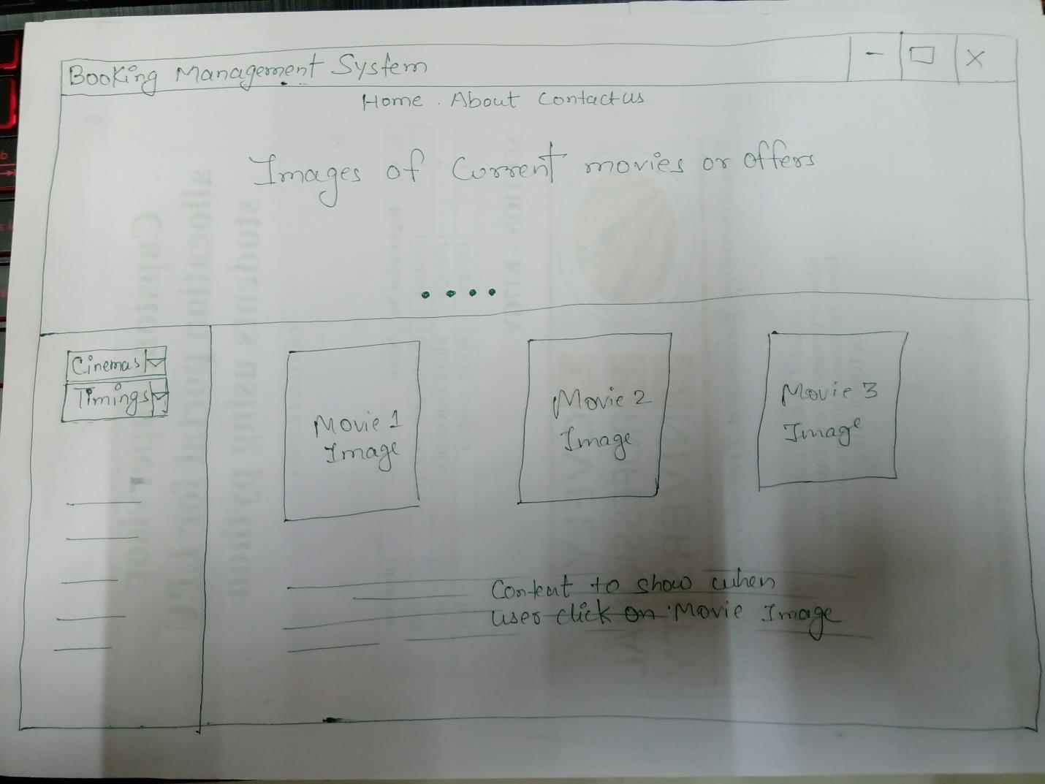

**FLOWCHART OF MANAGEMENT SYSTEM**

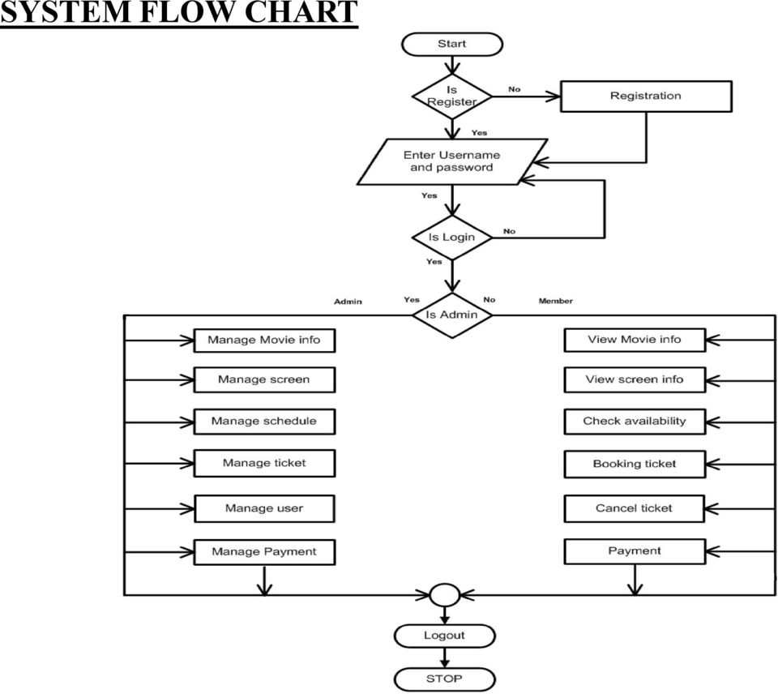

**DATA FLOW DIAGRAM OF BOOKING SYSTEM:**

***Zero level DFD :*** *Online Booking System*

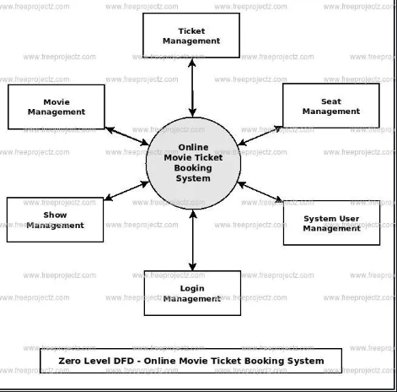

***First level of DFD :***  *online booking system*

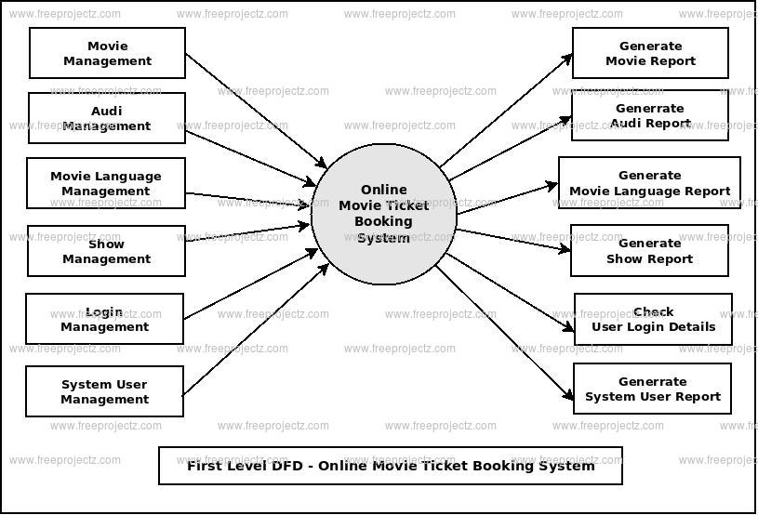

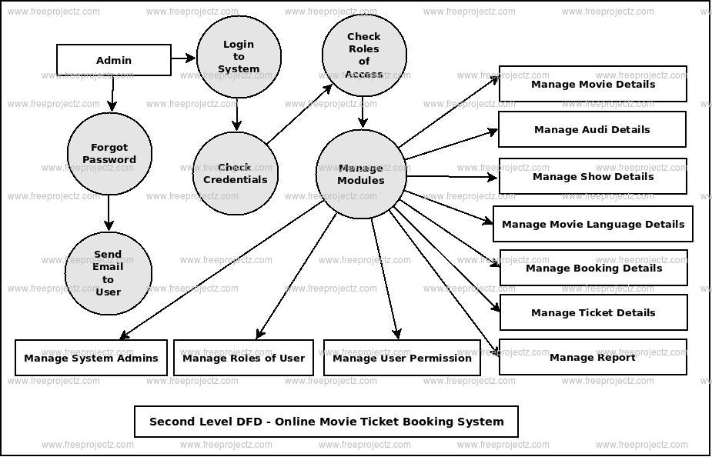 ***Second level of DFD :*** *online booking system*

**DESCRIPTION OF THE PROJECT**

We are preparing the website by using HTML ,CSS and java. Project had divided into three parts among the group members.

Firstly we had gathered the information about booking websites and also there startegies. And we started coding the marketing website via html, java and css.

CONTRIBUTION OF MEMBERS

Our group member Shreyansh have done the html design and used the java script code for implementation of website. Varun had done css styling for website and made the webpage outlay.

**SYSTEM DESCRIPTION**

• When the user will open the webpage , He/She will land at the title page where details will be provided which include “Home” , “About”, “Contact us”.

• The user will be able to see the current movie offers via images .

• If user wants to book a ticket the user has to click on the movie image .

•When user clicks on movie image he has to fill his details for successful booking.

• The user has the option to select the cinema and the Show timings

**MODULES OF WEBSITE**

* 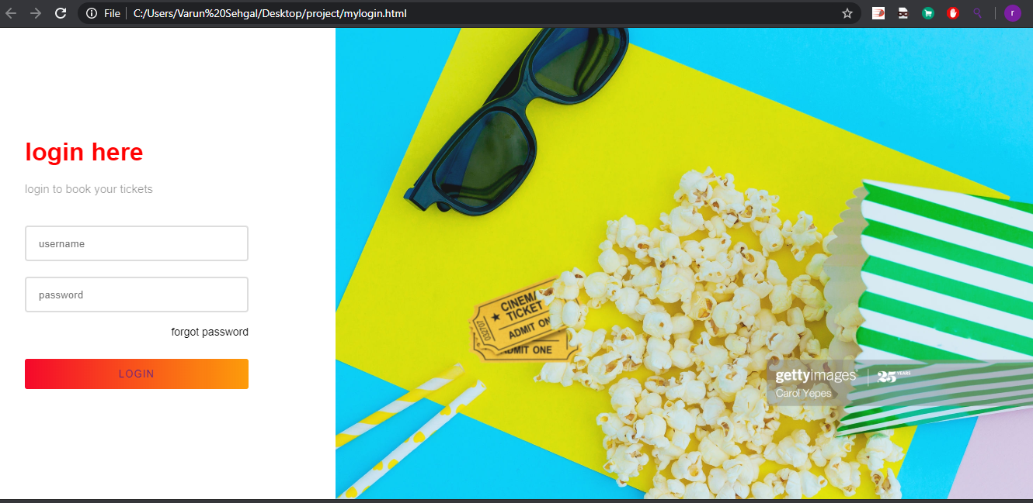Login Page

The following page is login page where user has to enter the username and password and click on login to enter the home page .

Here is the explanation of code for this –

1. We created right and left section using <div> tag and in right section insert a image using <img>tag
2. In left section we form a template of login using <input> tag and created textfield and password field
3. Then created a login button which takes us to the next page that’s it role of html now for styling we make a css file form.css and link it.
4. When you open this page there is animation in it by using animation delay in css and we use keyframes as well to carry out transition effect well.

* Movie Booking

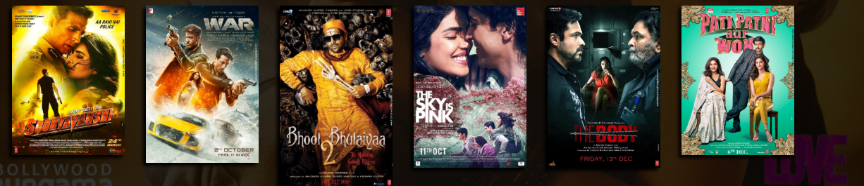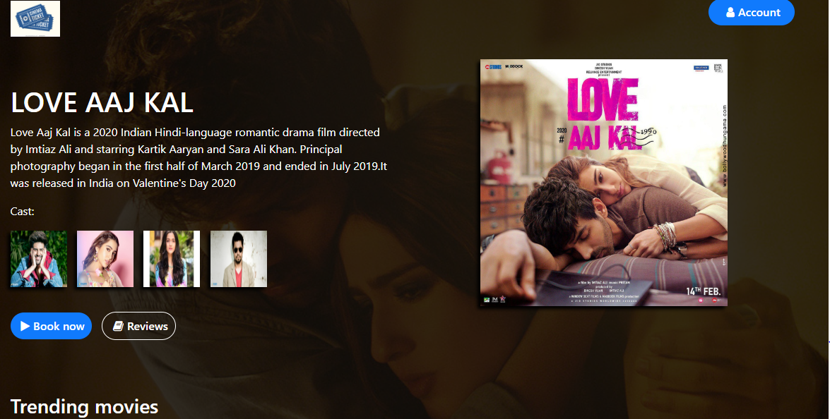

Here is the explanation for this page:

1. Firstly created many sections using <div>tag then place icon in top left section.
2. Then after we make a account button and place it in top right section
3. We place a beautiful image of a current movie in background.
4. Written about the movie and then place the images of cast of the movie.
5. When you move your cursor to the cast of movie it will show their name this can be done by using title attribute in <img> tag . now coming to css file.
6. We given background effect, padding, margin to all contents there is also use of box shadow that highlight the image well. There is transform:translateY which is for uplifting the other movies when cursor is moved on them.

* MOVIE TICKET BOOKING

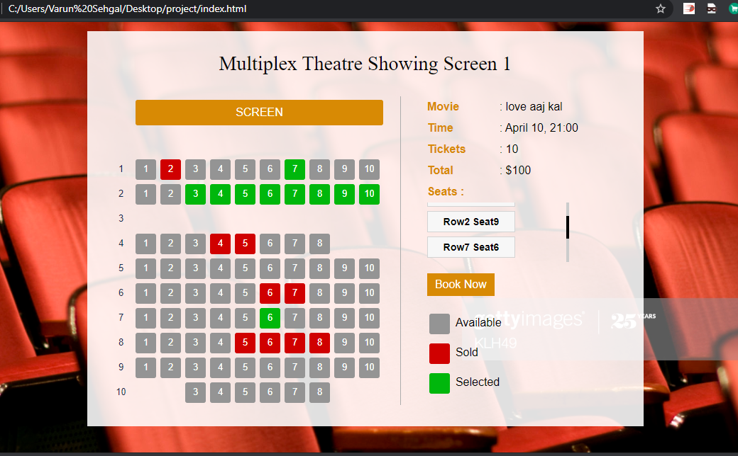

Now after selecting the movie , the costumer enters another page where he has option for selecting the available seats .

After selecting Seats the costumer has to click on BOOK NOW and his movie ticket gets booked.

Here is the explanation:

1. So here is the main use of javascript in the website
2. For calculating the price by selection of random seats by user.
3. There we code a loop if and else that if one seat is selected $20 is added in the price and so on
4. Also you can see your seat and row number this is also using javascript
5. We have written code of javascript in <script> tag in html file.
6. So moving to css we have done styling like colors, position of seats and background colour, padding, margin and many more.

**THANK YOU**